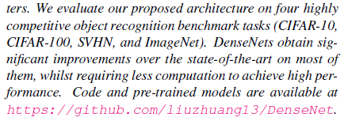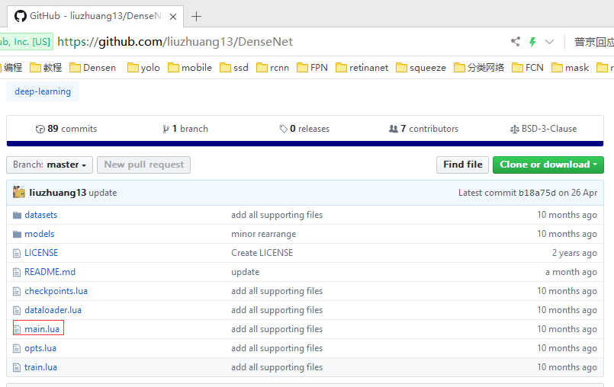
框架不同
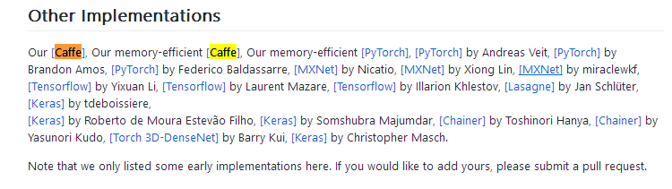

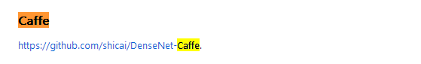
https://github.com/Tongcheng/DN_CaffeScript
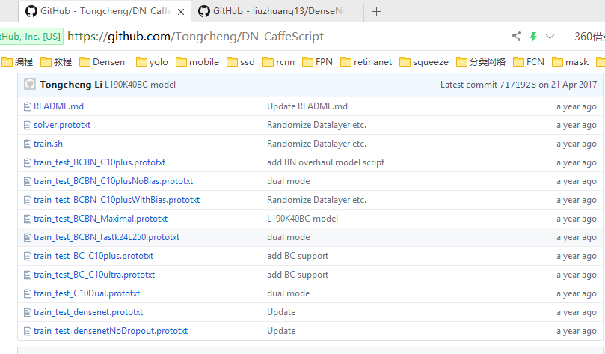
https://github.com/liuzhuang13/DenseNetCaffe
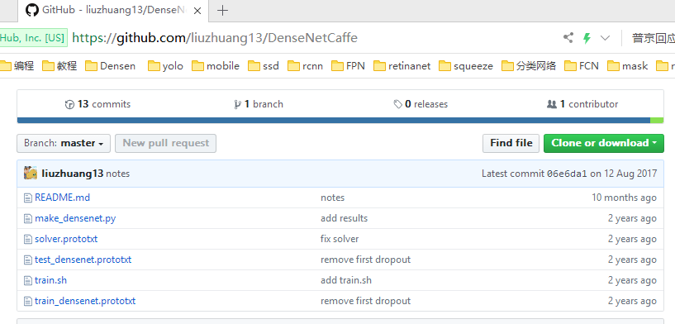
https://github.com/shicai/DenseNet-Caffe
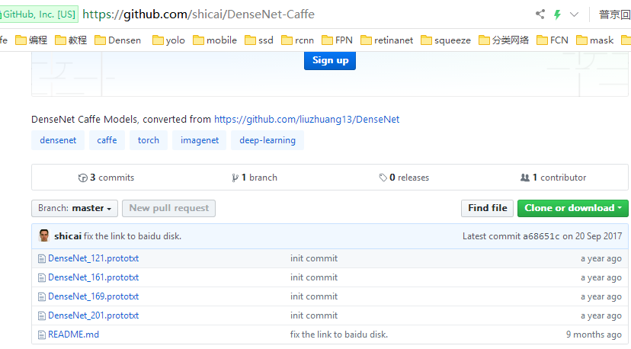

https://github.com/liuzhuang13/DenseNetCaffe
Usage
Get the CIFAR data prepared following the Caffe's official CIFAR tutorial.
make_densenet.py contains the code to generate the network and solver prototxt file. First change the data path in function make_net() and preprocessing mean file in function densenet() to your own path of corresponding data file.
By default make_densenet.py generates a DenseNet with Depth L=40, Growth rate k=12 and Dropout=0.2. To experiment with different settings, change the code accordingly (see the comments in the code). Example prototxt files are already included. Use python densenet_make.py to generate new prototxt files.
Change the caffe path in train.sh. Then use sh train.sh to train a DenseNet.

sun@ubuntu:~/DenseNetCaffe-master$ python make_densenet.py
sun@ubuntu:~/DenseNetCaffe-master$ sh train.sh
I0526 23:25:52.378542 55167 solver.cpp:330] Iteration 0, Testing net (#0)
I0526 23:43:08.965353 55171 data_layer.cpp:73] Restarting data prefetching from start.
I0526 23:43:29.050905 55167 solver.cpp:397] Test net output #0: Accuracy1 = 1
I0526 23:43:29.050990 55167 solver.cpp:397] Test net output #1: SoftmaxWithLoss1 = -nan (* 1 = -nan loss)
Killed

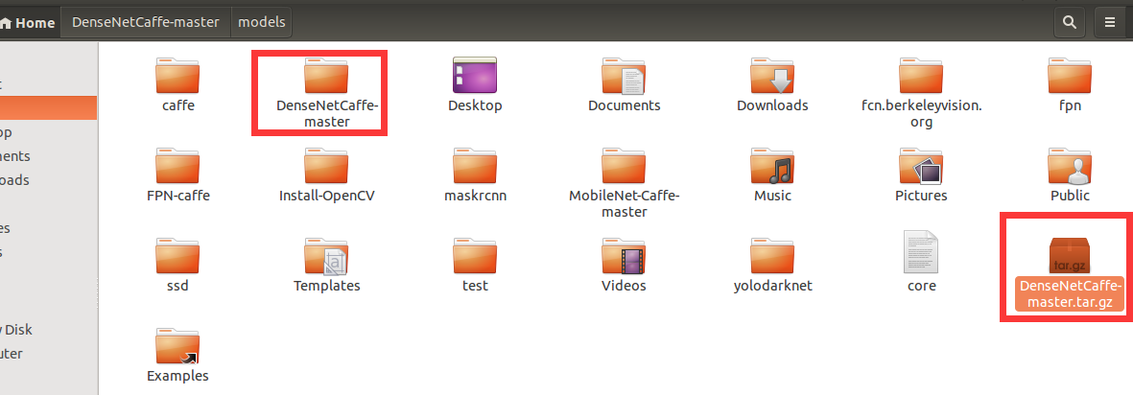
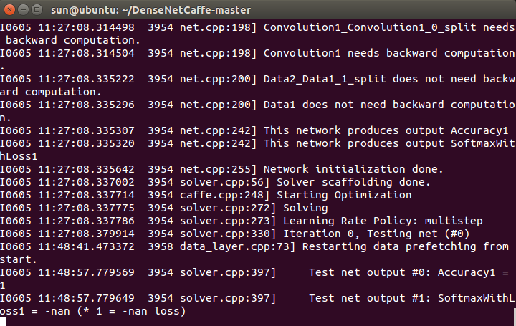
如果训练时报错说内存不足，可以考虑开虚拟内存；如果说GPU显存不足，可以通过修改make_densenet.py文件来修改batch_size参数来修改内存需求。
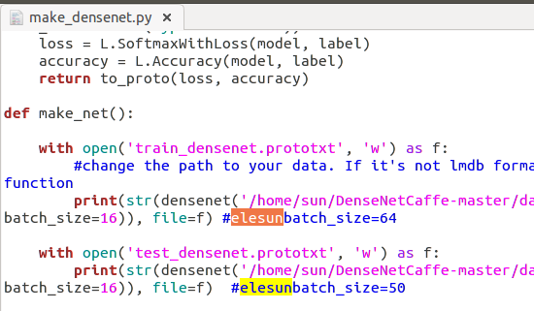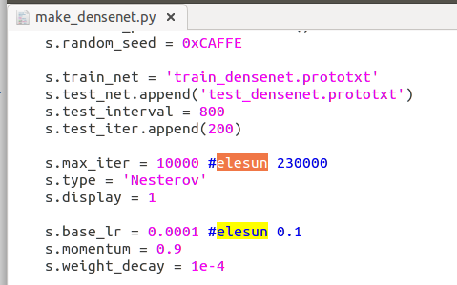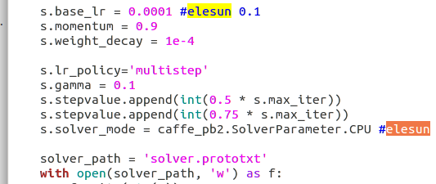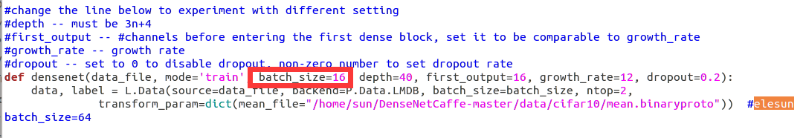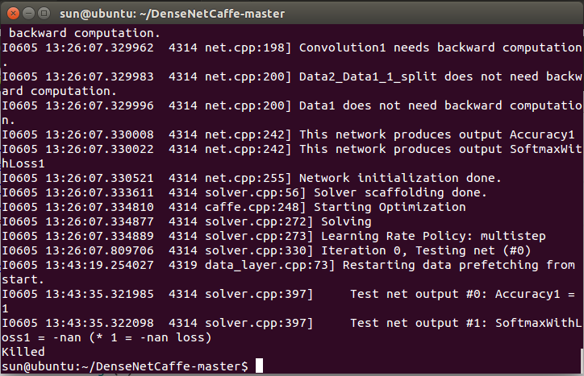

https://github.com/liuzhuang13/DenseNetCaffe/issues/20
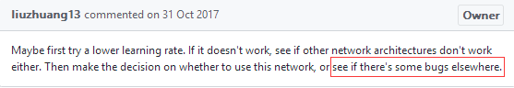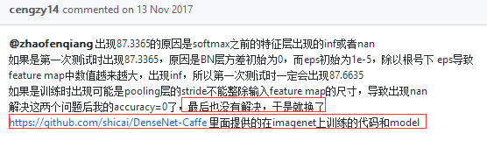

https://github.com/shicai/DenseNet-Caffe
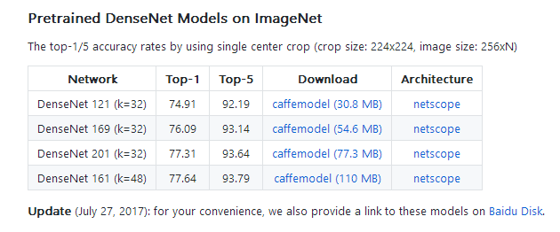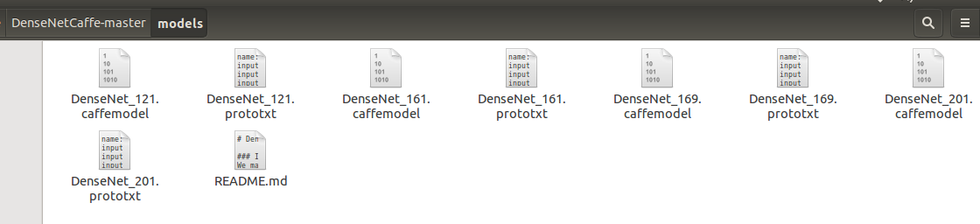

https://github.com/yuanyuanli85/DenseNet-Caffe
